Web site development

The home screen contains a Navbar, corousel and few cards displaying information about main menu of the restaurant. The three cards will be Veg Food, Non Veg Food and Chinese Food. It will also have a footer displaying Facebook, Insta and copy rights reserved.

Nav bar will look like the following


- Food Menu will have 3 options 1. Veg food 2.Non-Veg Food 3. Chinese Food.
- Credentials will have 2 menu items 1. Login Form 2. Registration Form.

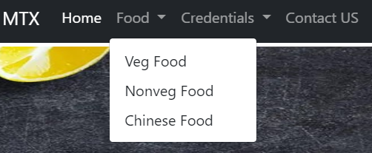

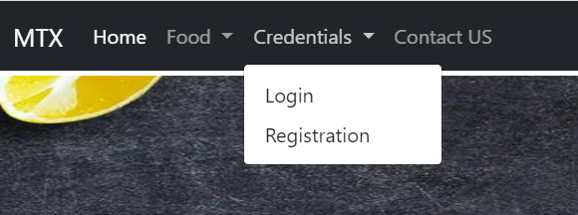

- On Click of Home menu item, main page should be displayed.
- On Click of Veg Food, A web page showing the veg food in the restaurant should be shown. The same applies to NonVeg Food and Chiense Food.
- On Click of Login menu item, it should display Login form. On click of Registration Menu item, it should display the registration form.
- Nav bar should be fixed on top. Even if we scroll down the page, navbar should be visible.
- Below the Navbar, courousel shold be there in the main Page.
- Contact us should display contact us page of the business.

Wireframe of the Main page is given below:
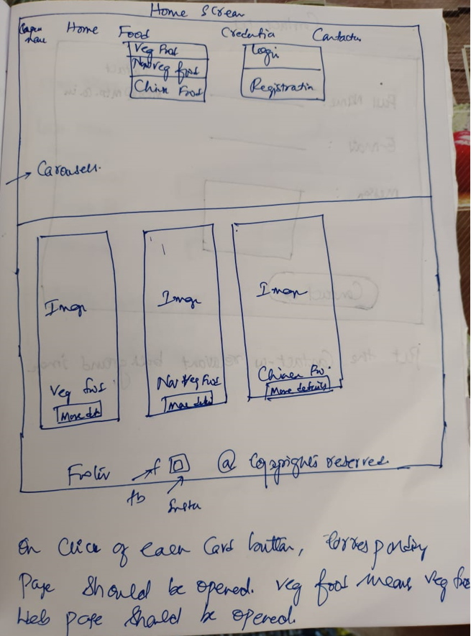

- Login Form --> Screen shot of the developed code is given:
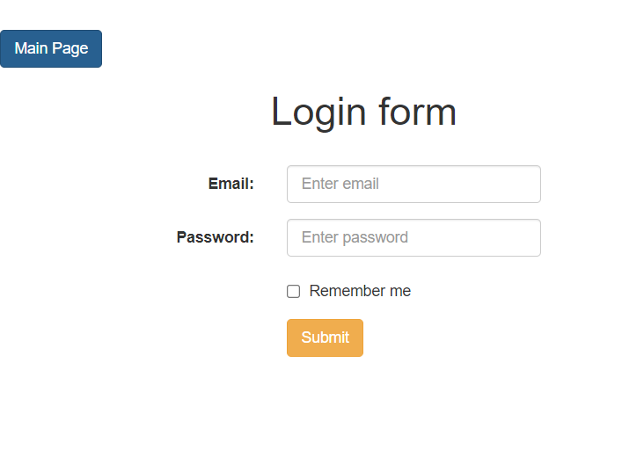

- Registration Form – Add a button in the Registration form as Main Page and on click of it, it should redirect to the main page.
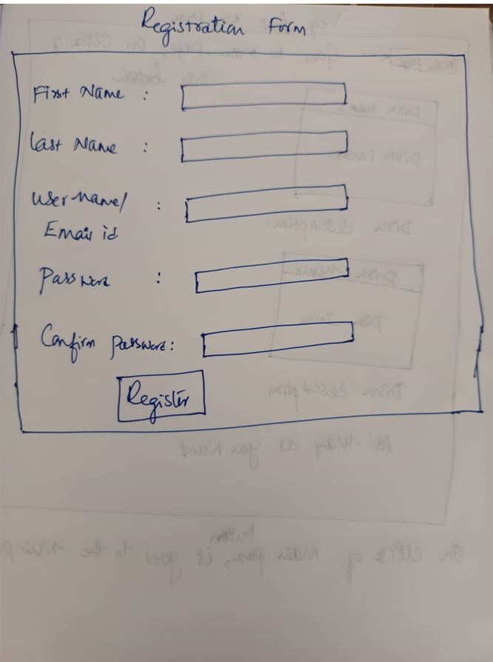

- Veg Food Web page
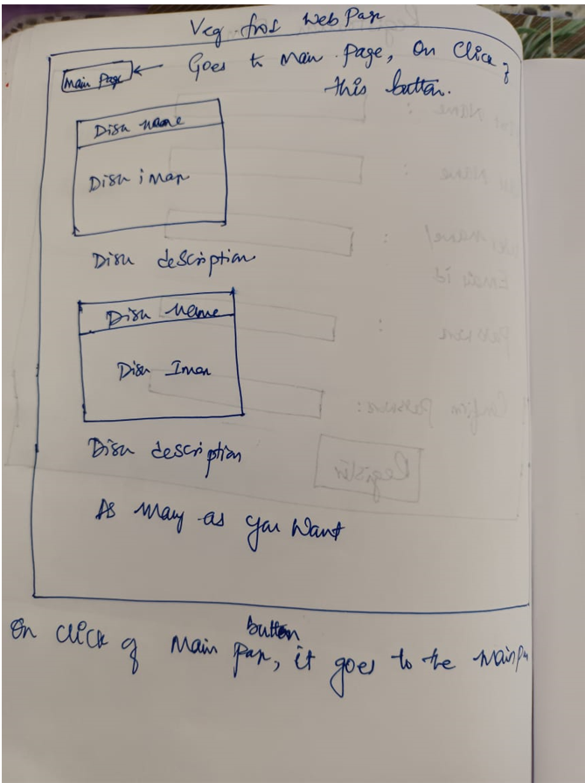

- Contact Us page.
